LAB ASSIGNMENT-3
DDL Questions (Data Definition Language)
1. Create the TEACHER table with the following attributes:
(Name, DeptNo, Date_of_Joining, DeptName, Location, Salary).
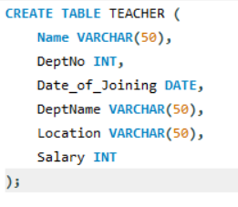
OUTPUT:
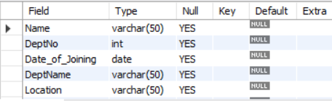
2. Create the SALES table with the following attributes:
(Sales_No, Salesname, Branch, Salesamount, DOB).
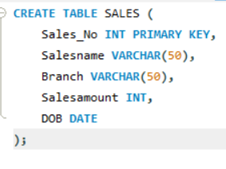
OUTPUT:
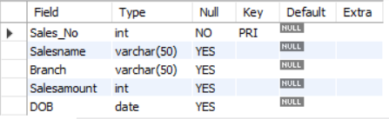

3. Create the DEPARTMENTS table with the following attributes:(dept_no, dept_name, dept_location).
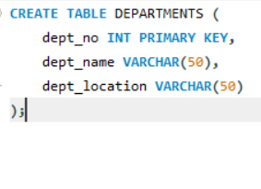
OUTPUT:
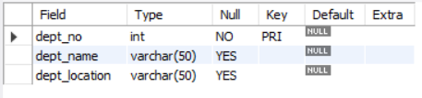

4. Create the EMPLOYEES table with the following attributes:
(emp_id, emp_name, emp_salary, dept_no).
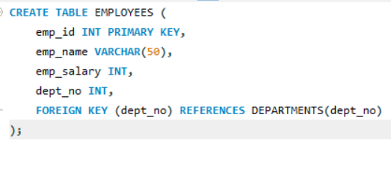
OUTPUT:
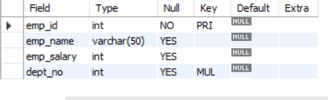

DML Questions (Data Manipulation Language)
From TEACHER Table
1.Insert five records into the TEACHER table.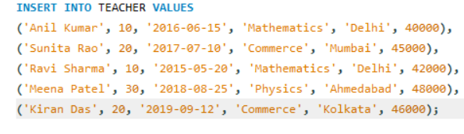
OUTPUT:
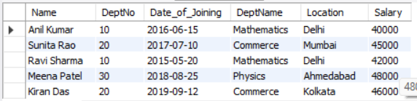
2.Give an increment of 25% salary to teachers working in the Mathematics department.
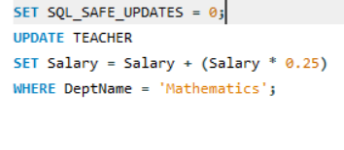
OUTPUT:
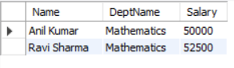
3.Give an increment of 15% salary to teachers working in the Commerce department.
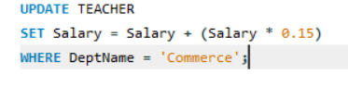
OUTPUT:
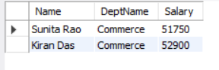
From SALES Table
1.Insert five records into the SALES table. 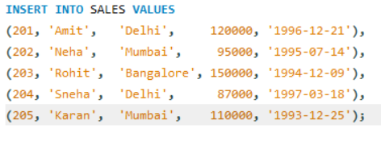
OUTPUT:
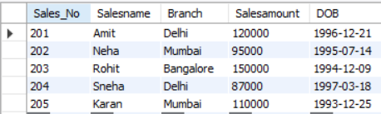

2.Calculate the total sales amount in each branch.
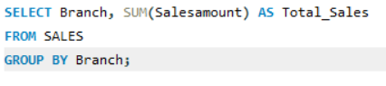
OUTPUT:
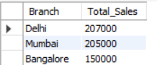

3.Calculate the average sales amount in each branch.
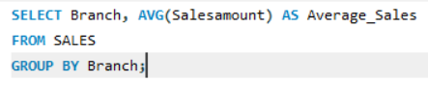
OUTPUT:
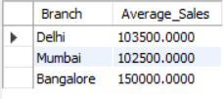
4.Display the Salesname and DOB of salesmen born in the month of December with date format like 21-Dec-09.
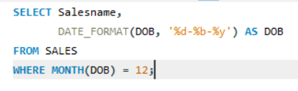
OUTPUT:
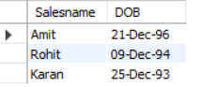

5.Display the Salesname and DOB of salesmen in alphabetical order of the month.
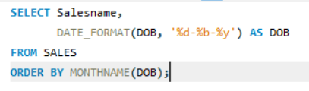
OUTPUT:
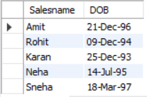

From JOIN Operations
1.Display employee details and department details where the department numbers are the same in both tables.
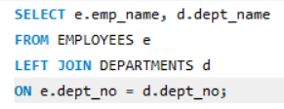
OUTPUT:
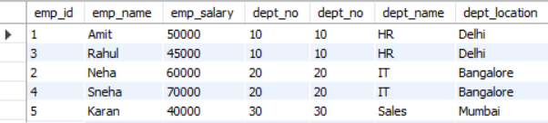
2.Display the employee name and department name using a LEFT OUTER JOIN.
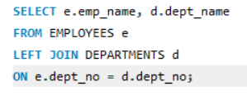
OUTPUT:
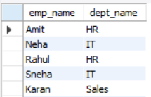

3.Display the employee name and department name using a RIGHT OUTER JOIN.
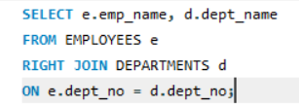
OUTPUT:
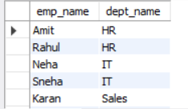

4.Display the details of employees who draw a salary greater than the average salary.
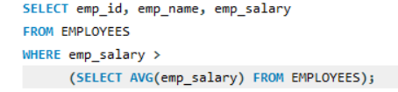
OUTPUT:
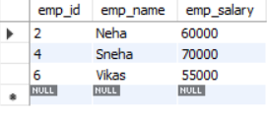

TCL Questions (Transaction Control Language)
1.Perform the ROLLBACK command on the TEACHER table.
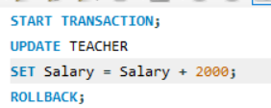
OUTPUT:
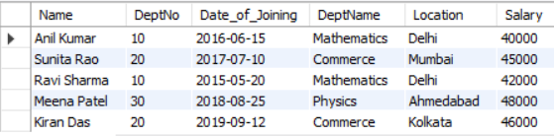

2.Perform the COMMIT command on the TEACHER table.
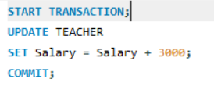
OUTPUT:
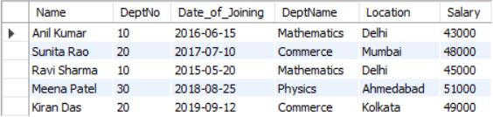

3.Write a query to implement a SAVEPOINT.
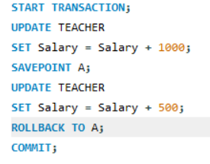
OUTPUT:
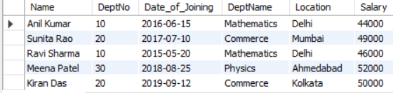

DCL Questions (Data Control Language)
1.Write a query to grant all privileges on the EMPLOYEES table to DEPARTMENTS.
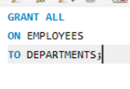
2.Write a query to grant selected privileges on the EMPLOYEES table to DEPARTMENTS.
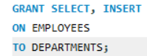

3.Write a query to revoke all privileges on the EMPLOYEES table from DEPARTMENTS.
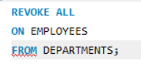
4.Write a query to revoke selected privileges on the EMPLOYEES table from DEPARTMENTS.
